1. We need multi vender theme this theme not multi vender.  
   <https://themeforest.net/item/cerato-multipurpose-elementor-woocommerce-theme/23323236?_ga=2.216670422.1385723081.1574725309-1094070115.1562371165>
2. Which of different between distribution partner and Business owner see this screenshot. 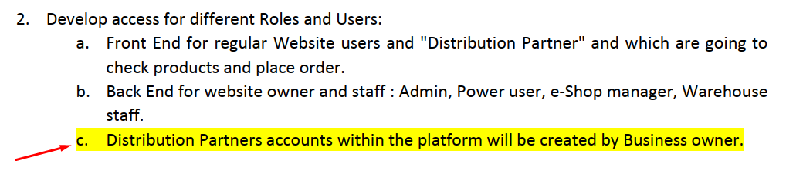
3. We need some premium plugin
   1. <https://yithemes.com/themes/plugins/yith-woocommerce-custom-order-status/>
   2. <https://codecanyon.net/item/woocommerce-product-filter/8514038>
   3. <https://woocommerce.com/products/ordercustomer-csv-export/?_ga=2.9434741.1392317165.1575640692-130782694.1568027182>